Residences of Clergy Members
of the
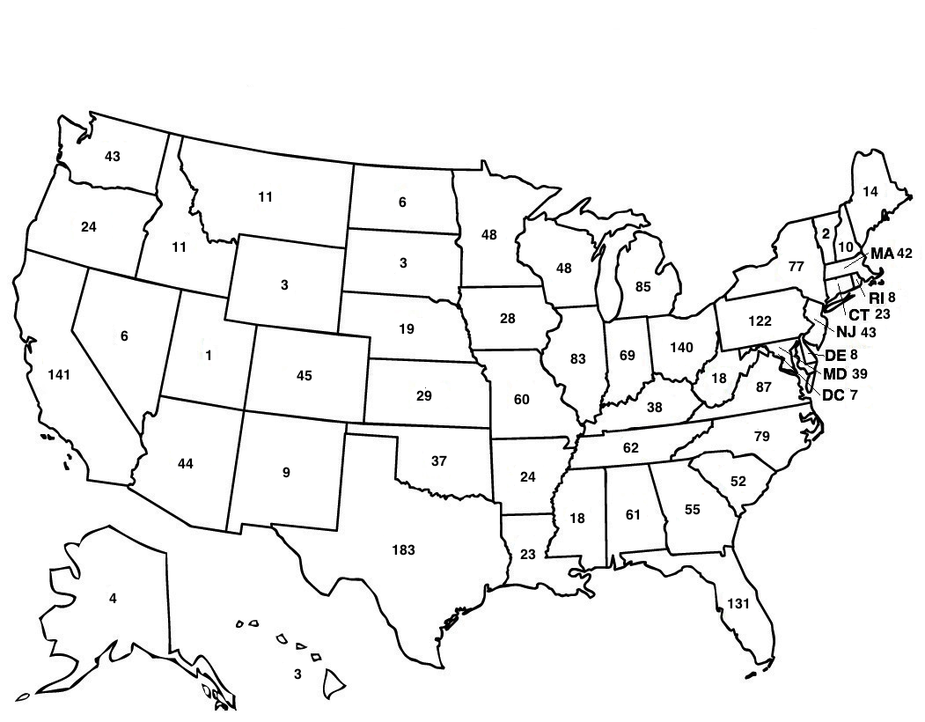
Coming Home Network International
Outside of the United States
Canada 85
United Kingdom 48
Australia 14
Germany 11
Sweden 9
Nigeria 8
Puerto Rico 7
India 6
Philippines 6
Israel 5
South Africa 5
Japan 4
Netherlands 4
Norway 4
Bosnia and Herzegovina 3
Estonia 3
Ireland 3
Kenya 3
Mexico 3
Albania 2
Benin 2
Brazil 2
China 2
Columbia 2
Ethiopia 2
Italy 2
Lithuania 2
Northern Ireland 2
Pakistan 2
Ukraine 2
Uruguay 2
Austria 1
Bahamas 1
Cambodia 1
Croatia 1
Denmark 1
Dominican Republic 1
Ghana 1
Guam 1
Guyana 1
Jamaica 1
Lebanon 1
Liberia 1
Malta 1
Mauritius 1
New Zealand 1
Peru 1
Romania 1
Spain 1
Singapore 1
Switzerland 1
Tanzania 1
Togo 1
Uganda 1
Uzbekistan 1

